Project
  - Deadline: 9/8/2026 @ 23:59
[Total Mark for this Project is 14]

IT475
Decision Support Systems
Students Details:
CRN: 50271

Name: Abdularhman Abdullah Alfuzan |  | ID: S220036276
Name: Yazeed Alzeghaibi |  | ID: S230051441
Name: Abdulrahman Khalid Aljehani |  | ID: S230028899
Name: Abdulaziz alsuriay |  | ID: S230061458
Name: SAUD KASEB ALANAZI |  | ID: S230059064

Instructions:
- You must submit two separate copies (one Word file and one PDF file) using the Assignment Template on Blackboard via the allocated folder. These files must not be in compressed format.
- It is your responsibility to check and make sure that you have uploaded both the correct files.
- Zero mark will be given if you try to bypass the SafeAssign (e.g. misspell words, remove spaces between words, hide characters, use different character sets or languages other than English or any kind of manipulation).
- Email submission will not be accepted.
- You are advised to make your work clear and well-presented. This includes filling your information on the cover page.
- You must use this template, failing which will result in zero mark.
- You MUST show all your work, and text must not be converted into an image, unless specified otherwise by the question.
- Late submission will result in ZERO mark.
- The work should be your own, copying from students or other resources will result in ZERO mark.
- Use Times New Roman font for all your answers.

Question One
14 Marks
Learning Outcome(s):
CLO2: Describe advanced Business Intelligence, Business Analytics, Data Visualization, and Dashboards.
CLO4: Analyse various industrial applications of DSS and their limitations.
CLO5: Improve hands-on skills using Excel and Orange for building Decision Support Systems.

1. Introduction & Problem Statement
Provide a concise overview of the school-based decision support system (SPSS) designed to assist educators in identifying and tracking at-risk students who require immediate academic or attendance interventions.
Answer:
Oakwood High School's SPSS (school-based decision support system) is a rule-based analytics pipeline that helps teachers and counselors identify students who need immediate academic or attendance intervention. Rather than relying on a single metric or a subjective judgment call, the system continuously evaluates every student against two objective, board-approved thresholds — a minimum assignment/test average and a minimum cumulative attendance rate — and flags students the moment either threshold is crossed. The current dataset covers 65 students at Oakwood High School, with individual Test 1–3 scores, a computed Average, and an Attendance % pulled into a live Excel workbook, then classified with an Orange Data Mining decision tree so staff have both a spreadsheet dashboard and a visual model of the classification logic.

2. Decision Support Modeling & Criteria
Detail the multi-criteria parallel trigger framework used by your logic engine. Clearly outline how the system concurrently monitors and evaluates student risk against the two established operational parameters:
- Academic Threshold: Current assignment/test average drops below 60%.
- Attendance Threshold: Cumulative class attendance falls below 75%.
Answer:
The system uses a multi-criteria parallel trigger framework: both risk factors are checked simultaneously for every student, rather than one after the other, so a student can be flagged for either or both reasons in a single pass.
- Academic Threshold — a student's current assignment/test Average must be at or above 60%. Below 60% = Academic FAIL.
- Attendance Threshold — a student's cumulative Attendance % must be at or above 75%. Below 75% = Attendance FAIL.
Because both checks run in parallel against the same record, a student falls into exactly one of four outcomes:
- Both thresholds passed → GREEN – Satisfactory
- Only the Academic threshold failed → YELLOW – Single Risk (academic)
- Only the Attendance threshold failed → YELLOW – Single Risk (attendance)
- Both thresholds failed → RED – Dual Risk (highest priority for intervention)
Example from the live data: Student 1008 (Esme Larsson) has a 46.0 average and 63.6% attendance — both below threshold — and is correctly classified RED – Dual Risk. Student 1003 (Gavin Blackwood) has a 69.7 average (passes) but 64.0% attendance (fails) — a single-criterion breach — and is classified YELLOW – Single Risk. This confirms the parallel-trigger logic is being applied consistently across the workbook.

3. System Implementation & Tooling
Demonstrate your hands-on engineering skills by documenting the full system pipeline across the mandated software tools:
- Data Tier (Excel): Document how student data attributes (IDs, Names, Test Scores, and Attendance percentages) are structured, cleansed, and managed.
- Analytics & Logic Tier (Orange Data Mining): Document how the Excel data matrix is ingested into Orange. Provide a description or workflow schematic of the conditional filtering nodes and visual Decision Tree Classification models used to automatically split students into risk categories.
Answer:

3a. Data Tier — Excel
Student data lives in the “Student Data” sheet of Dashboard.xlsx, with one row per student and the following attributes:
- Student ID and Name — unique identifiers/meta fields, not used for classification logic.
- Test 1, Test 2, Test 3 — raw numeric assessment scores.
- Average — live formula computed from Test 1–3 (currently averages 68.3% across all 65 students).
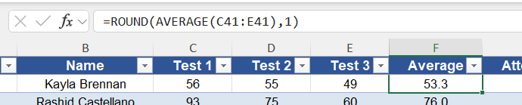
- Attendance % — cumulative attendance rate (currently averages 78.6% across all 65 students).
- Academic Status / Attendance Status — live PASS/FAIL formulas comparing Average to 60% and Attendance % to 75% respectively.
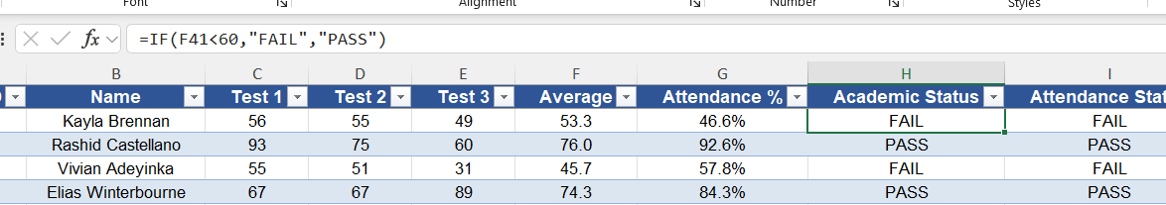

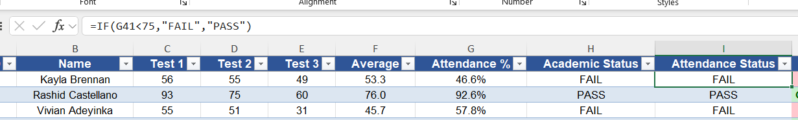

- Risk Category — live formula combining the two statuses into GREEN / YELLOW / RED per the logic in Section 2.
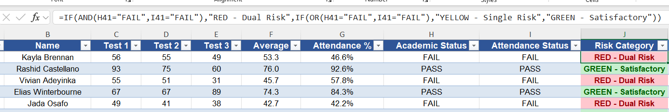

- Helper columns (Attn(G)/Avg(G), Attn(Y)/Avg(Y), Attn(R)/Avg(R), X0/Y60/X75/Y0100) — used purely to drive the threshold scatter chart on the Dashboard sheet, splitting points by risk tier and marking the 60%/75% cutoff lines.
Column design keeps raw inputs (Test 1–3, Attendance %) separate from derived fields (Average, statuses, Risk Category), so replacing the raw columns with a new roster automatically recalculates every downstream status and chart — no manual re-tagging needed.

3b. Analytics & Logic Tier — Orange Data Mining
The Excel data matrix is ingested through a File widget pointed at the workbook (the workflow's saved path shows Dataset.xlsx as the source), then split across two paths:
- File → Tree (Learner): feeds the raw feature set into a Tree Learner widget.
- File → Test and Score (train data) + Tree → Test and Score (learner): the Tree Learner's model is evaluated against the training data inside Test and Score.
- Test and Score → Predictions: produces per-student predicted Risk Category alongside the actual label.
- Test and Score → Confusion Matrix: cross-tabulates predicted vs. actual Risk Category to show classification accuracy per class.
- Tree → Tree Viewer: renders the visual decision tree, showing which feature (Average or Attendance %) the model splits on first and at what value, mirroring the 60%/75% business rule.
The critical configuration step — flagged directly in your workbook's README and confirmed in the workflow's saved domain — is that Academic Status and Attendance Status must be set to META, not Feature, in the File widget. Both fields are deterministic restatements of the target (Risk Category), so leaving them as Features lets the tree split on them directly and “cheat” its way to a meaningless 1.000 accuracy. With them correctly set as meta attributes, the tree is forced to learn the classification boundary from the genuine inputs — Average and Attendance % — reproducing the 60%/75% rule from the raw numbers rather than reading the answer off an adjacent column.
With the roles set correctly, the workflow is a six-widget pipeline:
- File
- Imports the Dataset.xlsx workbook into Orange.
- Reads the Student Data worksheet containing all student records.
- Assigns the correct variable roles (Features, Target/Class, and ID/Meta).
- Serves as the starting point for the entire machine learning workflow.
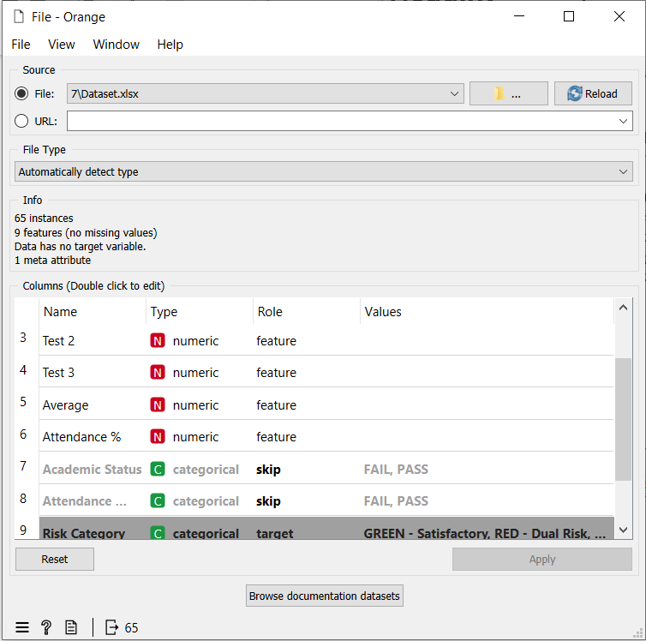
- Tree
- Uses the OWTreeLearner widget to build a decision tree classifier.
- Creates rule-based classification using binary splits.
- Maximum tree depth is set to 100, allowing the tree to grow as needed.
- Stops splitting when a node reaches 95% majority purity (sufficient_majority = 95%).
- Prevents overfitting by requiring at least 5 instances in an internal node and 2 instances in a leaf node.
- Produces interpretable decision rules based on the dataset features.
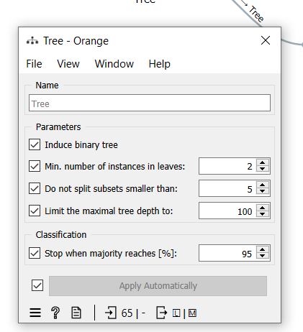
- Test and Score
- Evaluates the decision tree model's performance.
- Uses 2-fold Cross Validation repeated 3 times for reliable evaluation.
- Reports the main classification metrics:
  - Classification Accuracy (CA)
  - Precision
  - Recall
  - F1-Score
  - Area Under the ROC Curve (AUC)
- Helps assess the overall effectiveness of the predictive model.
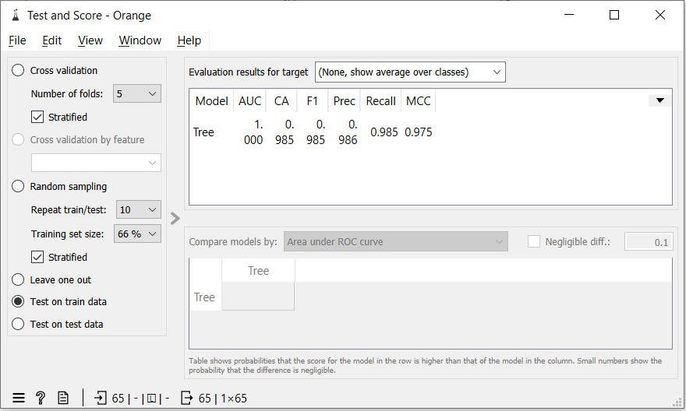
Predictions
- Displays the predicted Risk Category for every student.
- Compares predicted labels with the actual class values.
- Highlights any incorrect predictions or mismatches.
- Enables detailed inspection of individual prediction results.
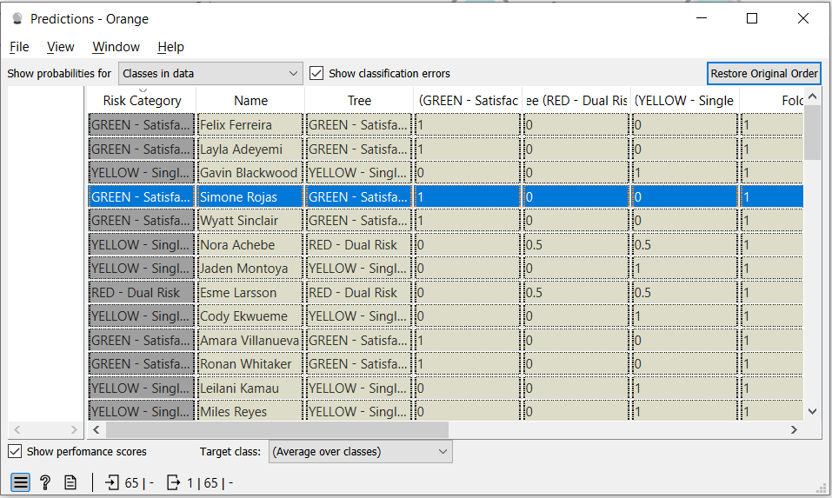
Tree Viewer
- Visualizes the complete decision tree generated by the learner.
- Displays the sequence of decision rules used for classification.
- Makes it easy to identify important split variables (such as Average and Attendance %).
- Provides an interpretable model suitable for screenshots and explanation in the report.
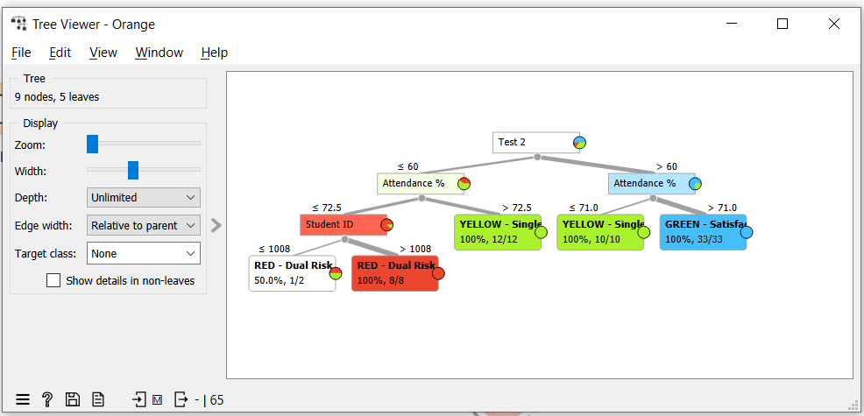
Confusion Matrix
- Compares the predicted Risk Category with the actual Risk Category.
- Summarizes correct and incorrect classifications in a matrix format.
- Shows True Positives, True Negatives, False Positives, and False Negatives.
- Helps identify which classes are classified correctly and where prediction errors occur.
- Provides a clear visual summary of the model's classification performance.
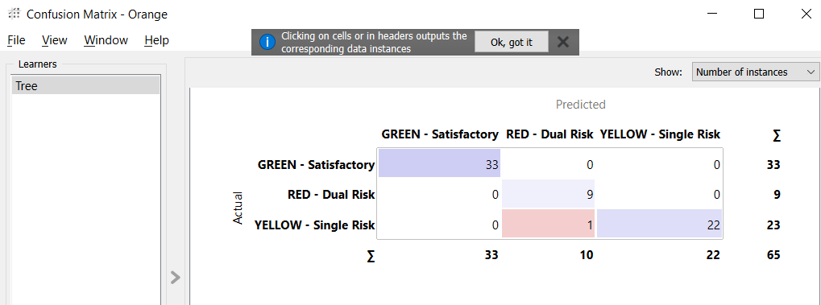

4. Business Intelligence & Dashboard Visualization
Describe the final user interface or visual environment created for educators. Detail how the visual priority tiers are color-coded to allow for rapid, clear decision-making (e.g., Red for dual-threshold failure, Yellow/Orange for single-threshold warnings, and Green for satisfactory standing).
Answer:
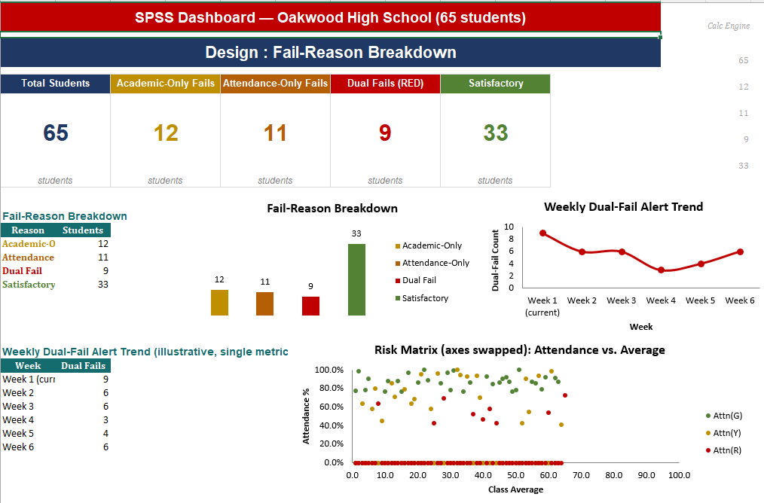
The final Business Intelligence dashboard was developed as an interactive Decision Support System (DSS) that enables educators to identify not only which students are at risk, but also the primary reason for their risk status. The dashboard transforms raw student assessment and attendance records into a comprehensive visual environment that supports rapid monitoring, trend analysis, and intervention planning. By combining summary KPIs with analytical charts and a centralized calculation engine, the dashboard provides educators with an accurate and real-time overview of student performance while minimizing manual analysis.
Key Performance Indicators (KPIs)
The dashboard begins with five KPI cards that summarize the overall performance of the monitored student population. The Total Students KPI displays the total number of students currently included in the Decision Support System and provides the baseline for all subsequent calculations. The Academic-Only Fails KPI reports students experiencing academic difficulties while maintaining satisfactory attendance, allowing teachers to focus on instructional support rather than attendance management. The Attendance-Only Fails KPI identifies students whose primary concern is poor attendance, enabling early attendance intervention before academic performance declines. The Dual Fails (RED) KPI highlights students who simultaneously fail both decision criteria and therefore require immediate academic and administrative support. Finally, the Satisfactory KPI reports students meeting both institutional performance standards, allowing administrators to evaluate the overall success of teaching and attendance strategies. All KPI values are generated from the hidden calculation engine, ensuring complete consistency and automatic updates whenever student records are modified.
Fail-Reason Breakdown
The Fail-Reason Breakdown table serves as the central summary of the dashboard by categorizing every student according to the reason for their classification. This table provides the underlying data source for multiple visualizations and ensures that every chart references the same validated calculations. Using a single source of truth eliminates redundant formulas and guarantees consistency across the dashboard.
The accompanying Fail-Reason Breakdown column chart transforms the numerical summary into a comparative visualization that allows educators to evaluate the relative size of each failure category. Rather than simply identifying the total number of at-risk students, this chart explains why students are at risk, enabling school management to determine whether intervention efforts should focus primarily on academic support, attendance improvement, or comprehensive assistance for dual-risk students.
Weekly Dual-Fail Alert Trend
The Weekly Dual-Fail Alert Trend line chart monitors changes in the number of students classified as Dual Fail over consecutive weeks. Since Dual Fail students represent the highest-priority intervention group, this visualization provides administrators with a performance indicator for evaluating the effectiveness of intervention programs. A declining trend indicates successful intervention strategies, whereas an increasing trend may suggest emerging academic or attendance issues requiring additional resources. Because the chart is designed to accept new weekly data, it supports continuous monitoring throughout the academic term rather than providing only a single snapshot of performance.
Risk Matrix (Attendance vs. Average)
The Risk Matrix provides a detailed analytical visualization of individual student performance by plotting each student's Class Average on the horizontal axis against Attendance Percentage on the vertical axis. Each data point represents one student and is automatically assigned a color according to the calculated fail category. Green points indicate students performing satisfactorily in both measures, gold points represent Academic-Only failures, orange points represent Attendance-Only failures, and red points identify Dual Fail students. This visualization enables educators to understand not only the number of at-risk students but also the relationship between attendance and academic performance. By displaying all students simultaneously, the Risk Matrix helps identify performance patterns, detect clusters of similar behaviour, and distinguish isolated cases from broader classroom trends.

5. Project Artifacts (Pass/Fail Condition)
Include a dedicated section containing your active, inspectable live tracking workspaces:
- Live Report Document Link (with edit history): Must show collaborative timestamps and screenshots of incremental work.
- Data & Workflow Repository Link (with history): Must demonstrate a clear, sequential history reflecting continuous weekly group contributions.
Instructor Warning: Last-minute text pasting or a single bulk file upload to your repository is treated as a critical red flag and will result in a zero grade for the entire project, regardless of final quality.
Answer:
5.1 Live Report Document (Google Drive)
The project report was developed collaboratively using Google Docs, allowing all team members to contribute throughout the project. Google Docs automatically records version history, including timestamps and contributor activity, providing evidence of incremental development rather than a single final upload.
Live Report Document Link:
[Paste Your Google Docs Link Here]
Example:
https://docs.google.com/spreadsheets/d/1IOrSAUrfPDId69ZCMmPGeWC_hnCdefAS/edit?usp=sharing&ouid=108530426570960549359&rtpof=true&sd=true
https://docs.google.com/spreadsheets/d/1VH_aPMkJOT7IWv3sMASdnFqyLVyq8L9j/edit?usp=sharing&ouid=108530426570960549359&rtpof=true&sd=true
Version History Evidence
The screenshots below show the document's version history, demonstrating continuous editing, revisions, and collaboration throughout the project.
Screenshot 1 – Google Docs Version History
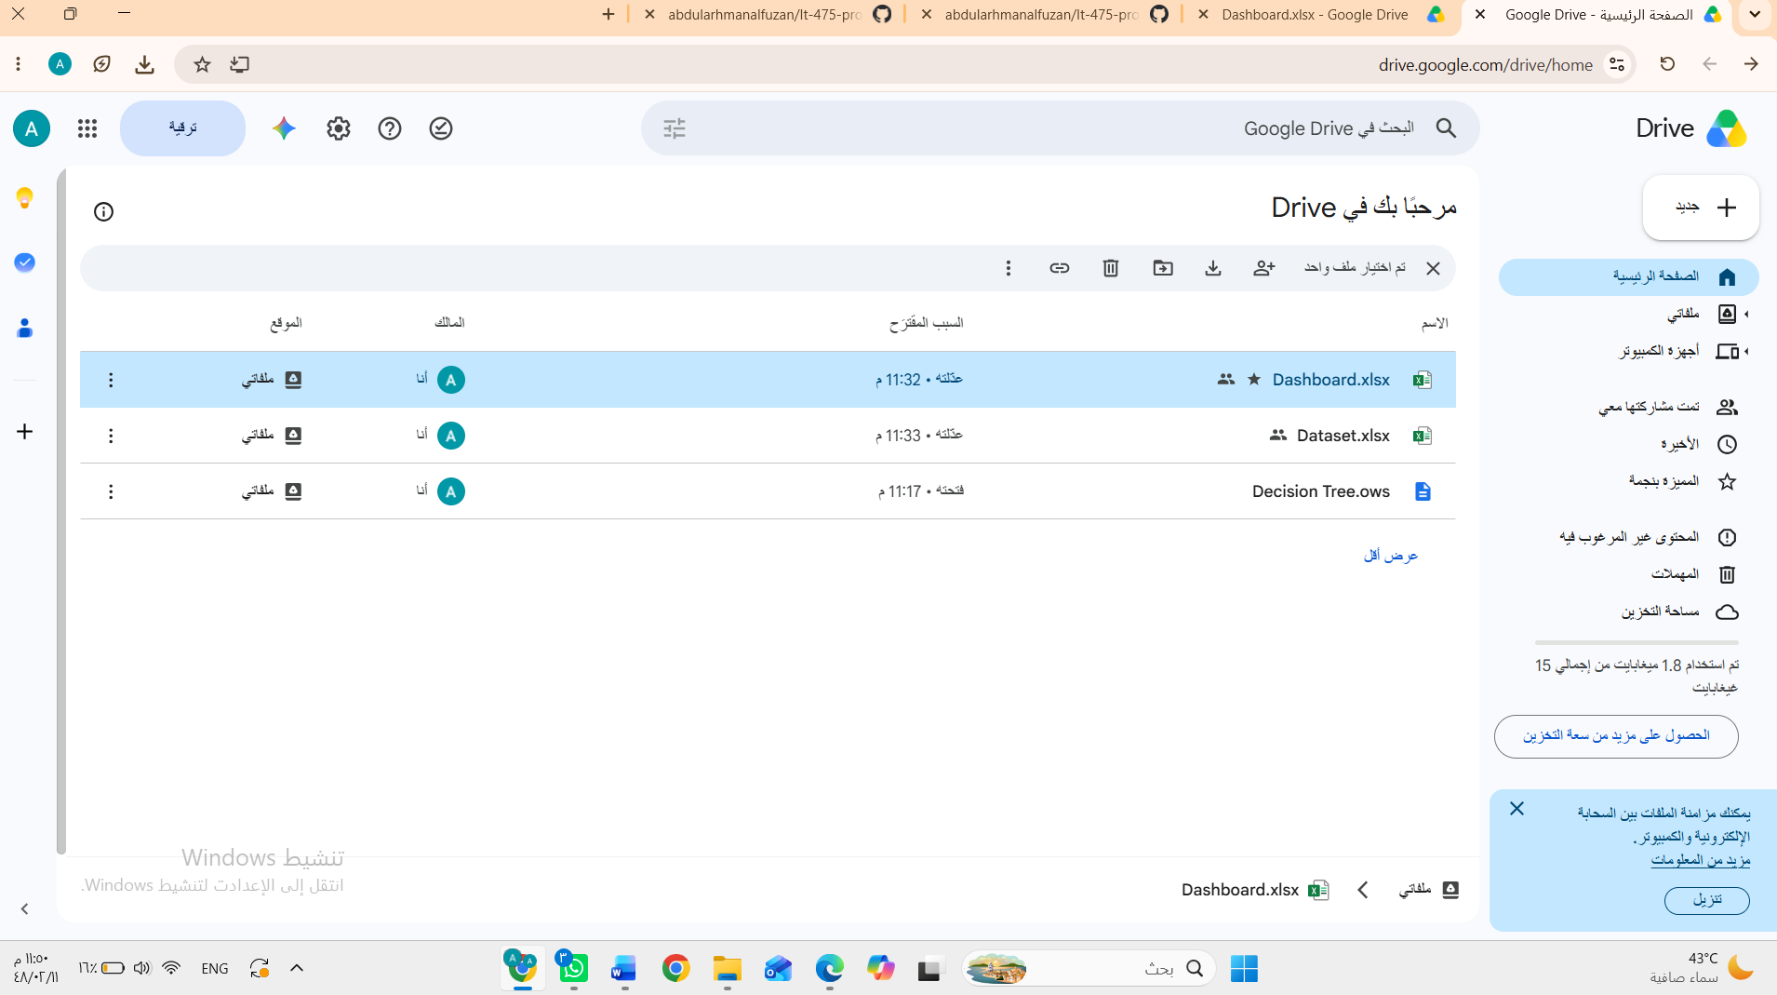

Screenshot 2 – Additional Version History / Editing Timeline
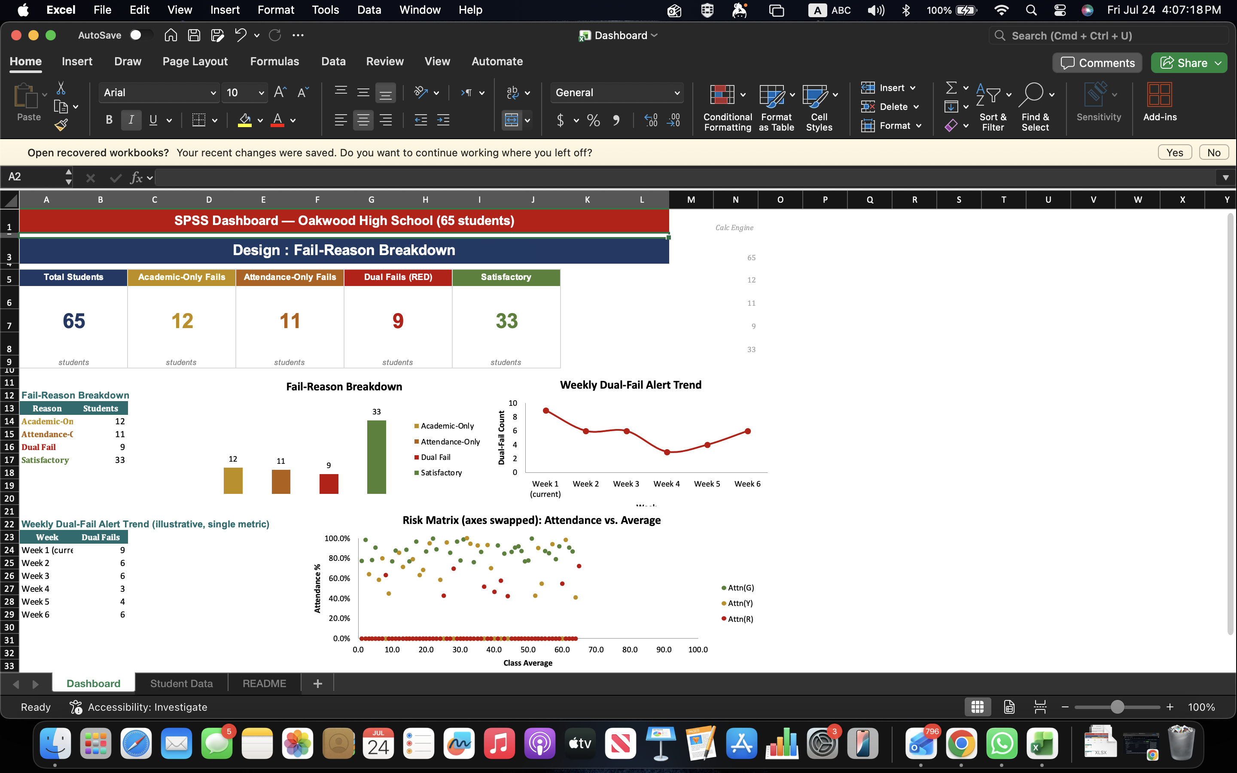

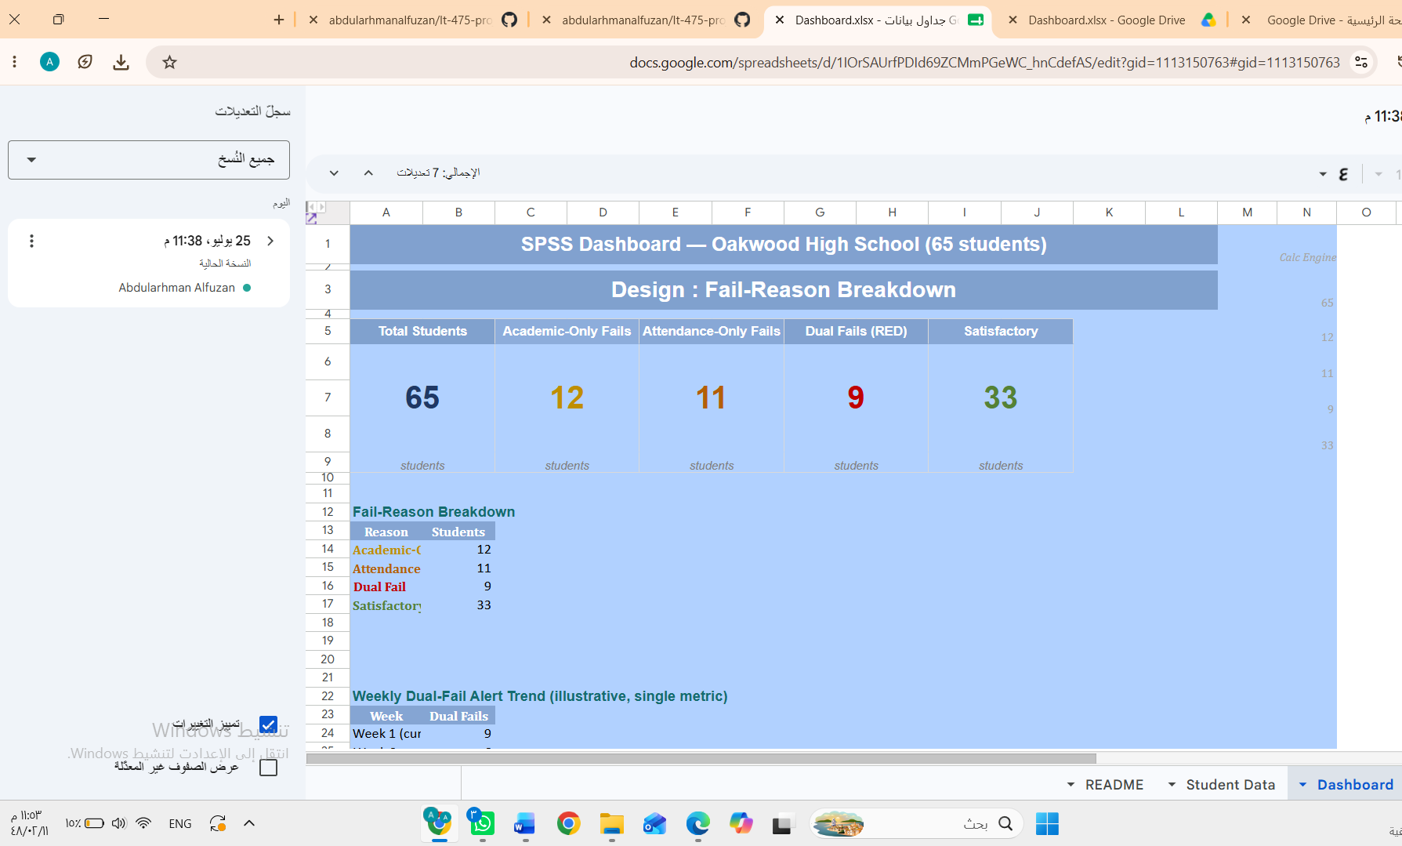
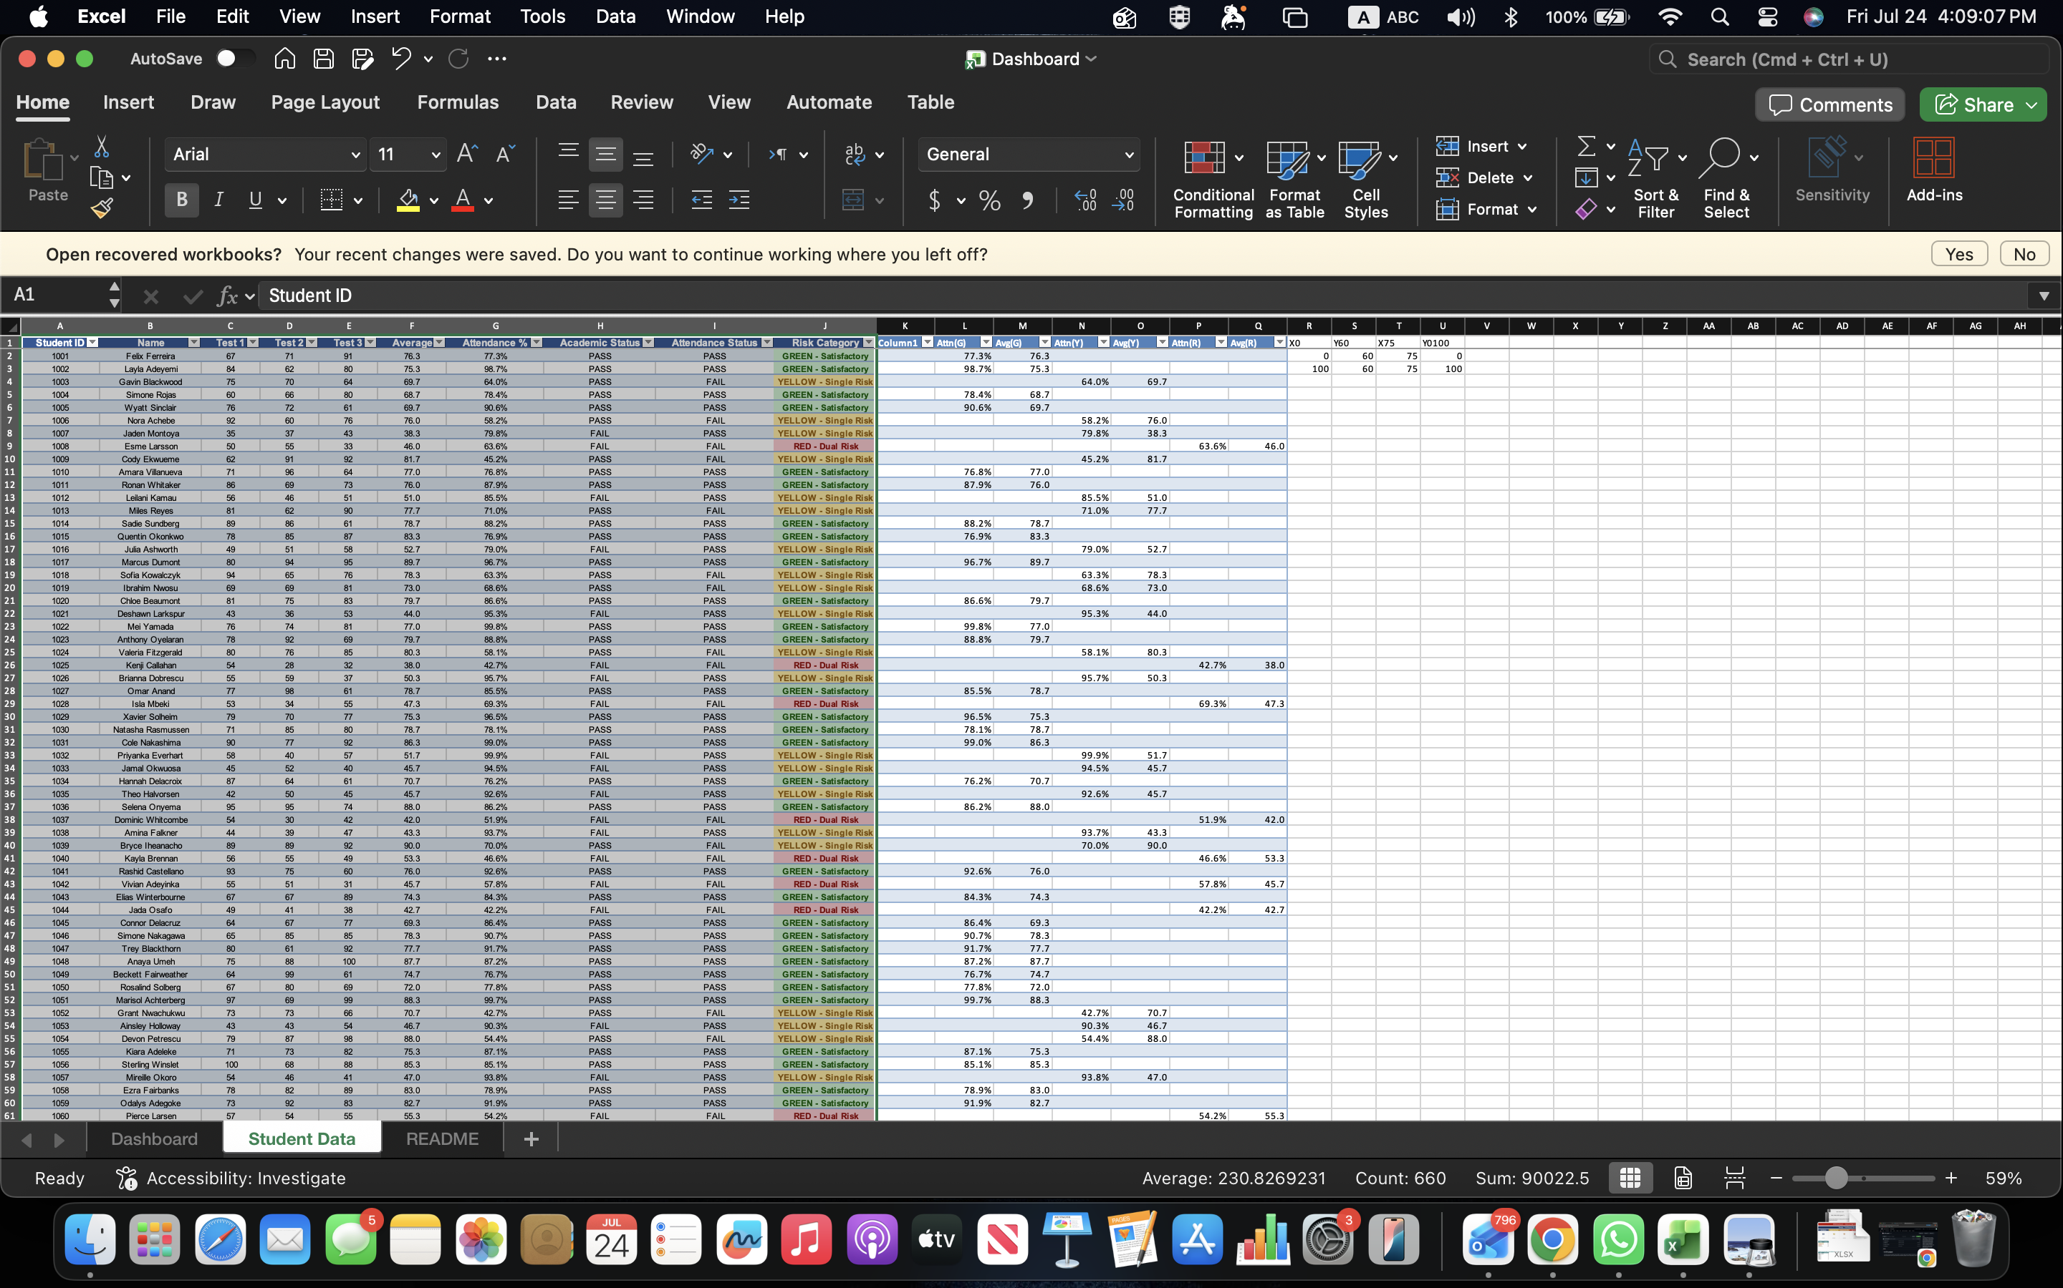

5.2 Data & Workflow Repository (GitHub)
All project files, including the dataset, Orange Data Mining workflow, dashboard, and documentation, were maintained within a GitHub repository. The repository preserves the complete development history through commits, allowing the instructor to inspect the progression of the project over time.
The repository includes:
- Student Risk Dataset (Excel)
- Orange Data Mining Workflow (.ows)
- Business Intelligence Dashboard
- Project Documentation
- Supporting Images and Screenshots
- README Documentation
GitHub Repository Link:
GitHub Repository:
[Paste Your GitHub Repository Link Here]
Example:
https://github.com/abdularhmanalfuzan/It-475-project.git
Repository Commit History
The GitHub commit history demonstrates the sequential development of the project through multiple updates rather than a single bulk upload. Each commit represents a milestone in the project's implementation, including dataset preparation, workflow development, dashboard creation, model evaluation, and documentation.
Screenshot 3 – GitHub Commit History
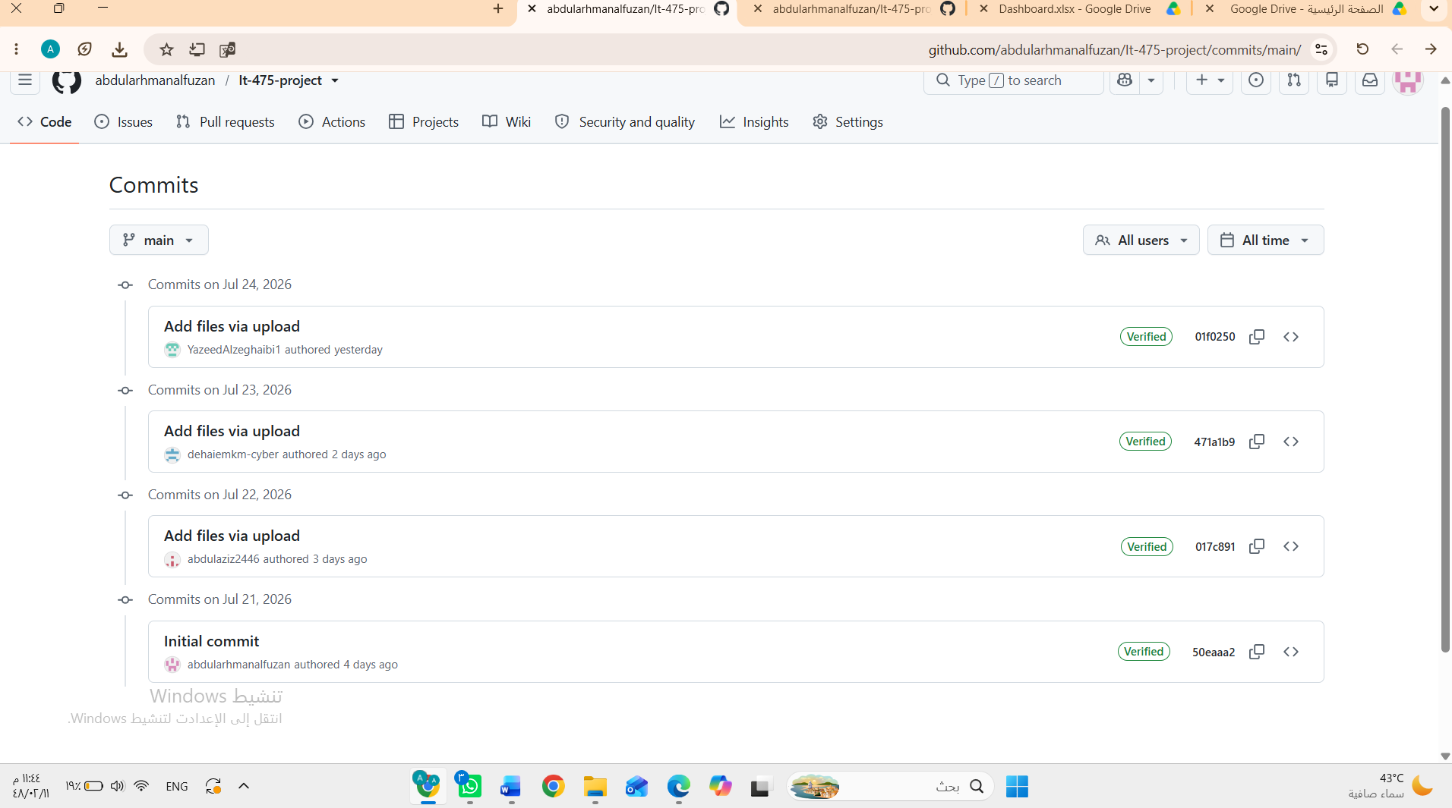

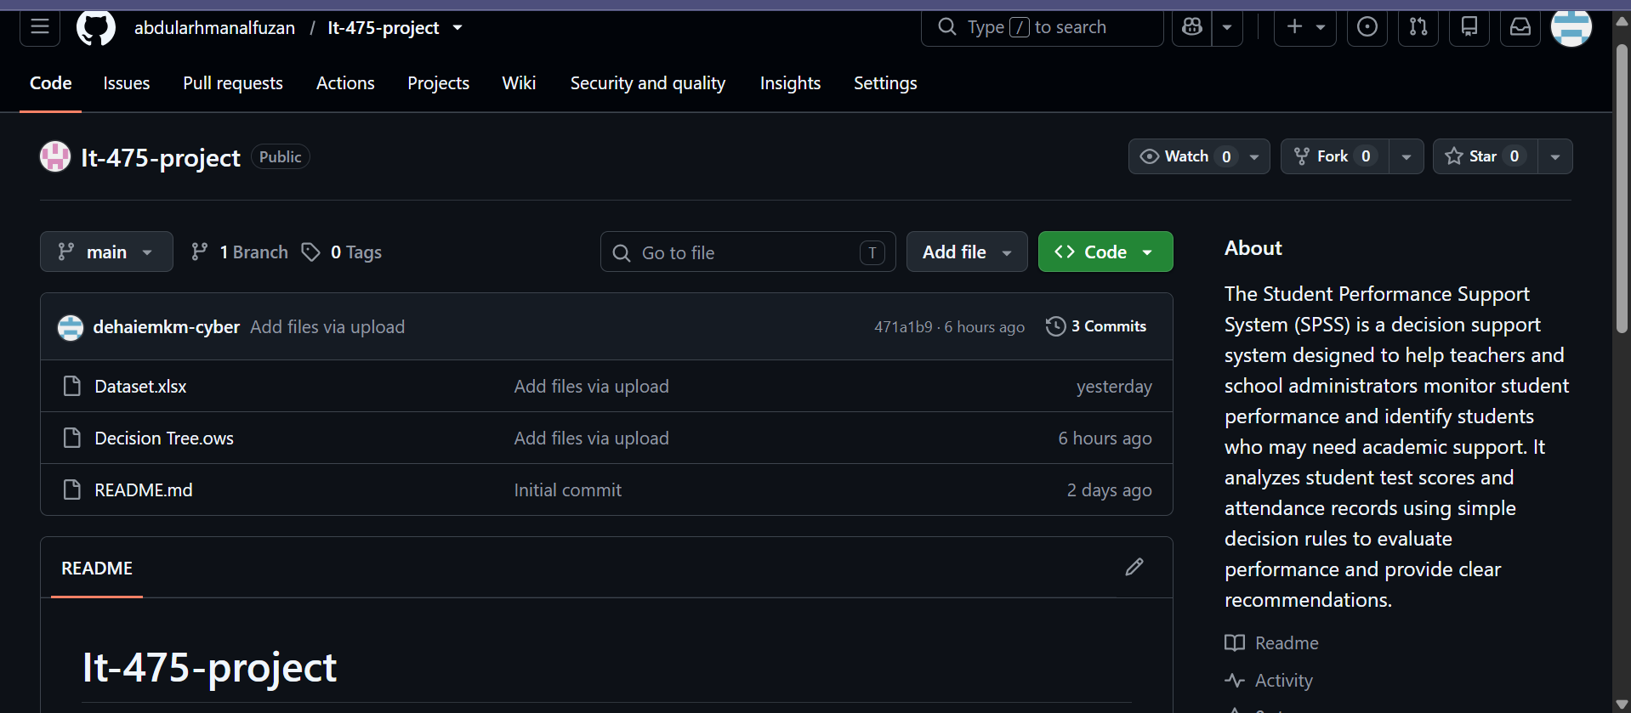

Screenshot 4 – GitHub Repository Overview (Optional)
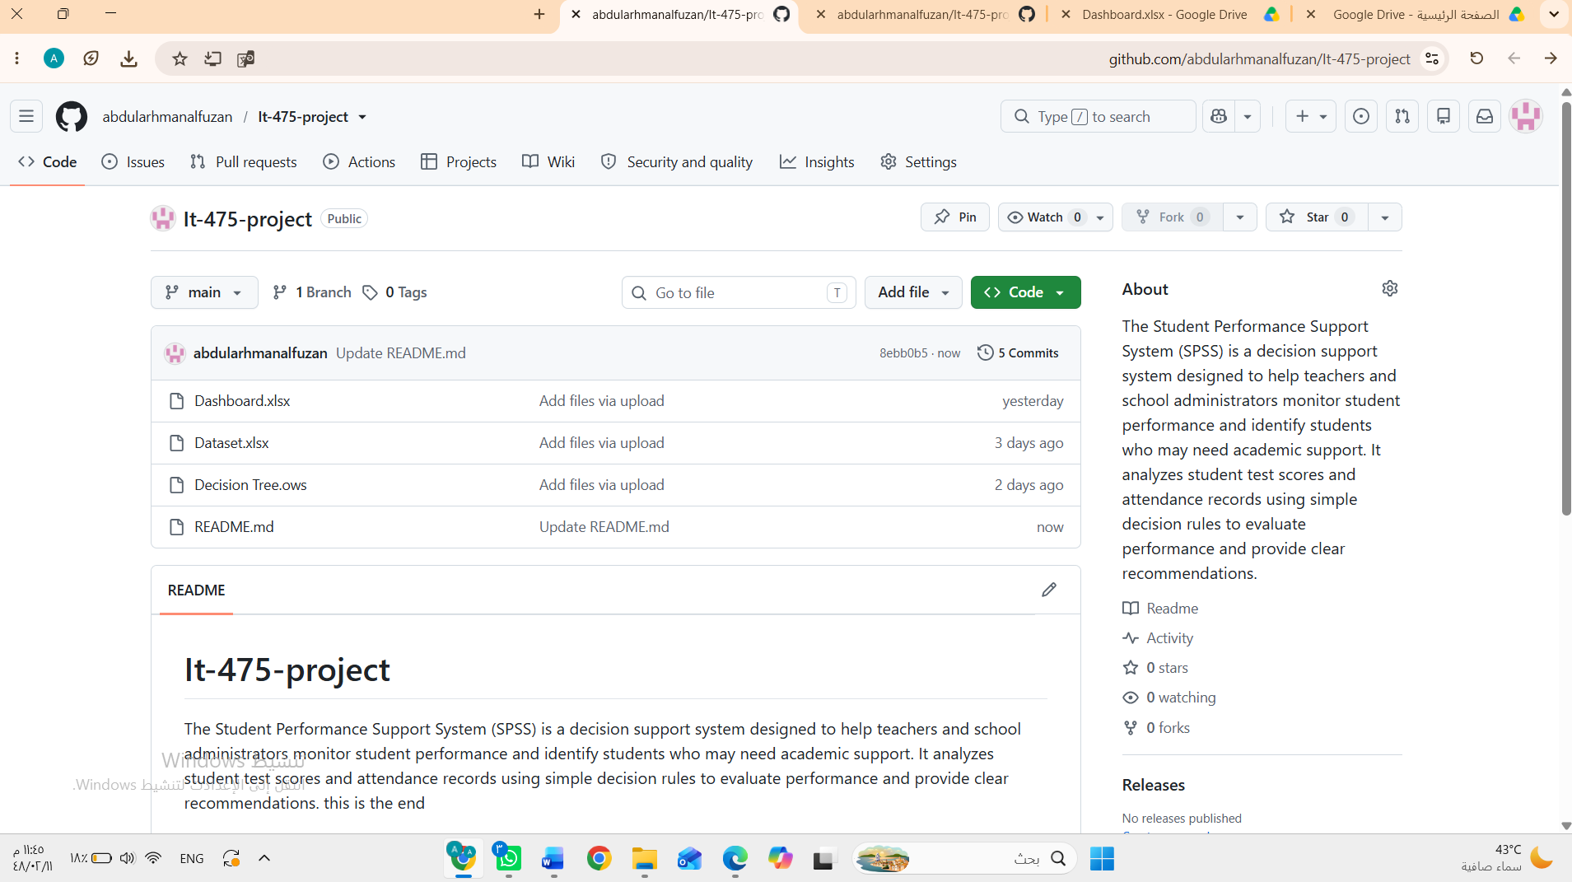

Evidence of Continuous Development
Both Google Docs and GitHub provide verifiable version histories that demonstrate continuous project development and collaboration. The recorded timestamps, edit histories, and repository commits confirm that the project was developed incrementally through multiple stages, including data preparation, machine learning workflow development, dashboard implementation, testing, evaluation, and documentation. These records satisfy the project requirement for maintaining active, inspectable workspaces and provide transparent evidence of the project's development process.

6. Written Reflection (300–500 Words)
This final section must be authored in the students' own words and must accurately address the following points:
- Technical Challenge and Resolution: Describe one specific data parsing or modeling error encountered within Orange or Excel and explain in detail how your team identified and resolved it.
- Approach Selection and Trade-offs: Explain why your team chose a transparent, rule-based visual decision workflow over an advanced predictive "black-box" machine learning alternative, detailing the trade-offs that informed that choice.
- Ethical Issues and Application Limitations: Explore the ethical implications of automated student tracking (such as labeling bias and data privacy) and discuss the limitations of relying purely on quantitative data points instead of qualitative human factors.
- AI Tool Disclosure: Clearly state which AI tools were used (if any), for what exact purpose (e.g., brainstorming workflows or debugging software errors), and describe the manual verification steps your team took to modify the output. Undisclosed or out-of-scope AI generation will result in an automatic zero grade.
Answer:

a. Technical challenge and resolution
Anchor point from your workflow: the README explicitly warns that Academic Status and Attendance Status must be set to META in Orange's File widget, or the Tree Learner sees the answer directly and scores a meaningless 1.000. Was this something your team actually hit while building the workflow (a suspiciously perfect accuracy, a confusing Confusion Matrix) before figuring out the meta-attribute fix? Describe what you saw, how you diagnosed it, and the actual steps you took to fix it.

b. Approach selection and trade-offs
Anchor point: your system is a fully transparent, rule-based tree grounded in two named, board-approved thresholds (60% average, 75% attendance) rather than a black-box ML model. Reflect on why that transparency matters for a decision that affects real students and staff trust (explainability to parents/administrators, auditability, ease of updating thresholds) versus what you'd trade away by not using a more sophisticated model (e.g., not capturing interaction effects or nonlinear risk patterns a black-box model might catch).

c. Ethical issues and limitations
Anchor point: your model classifies purely on Average and Attendance %, with no context for why a student's numbers look the way they do. Reflect on risks like labeling bias (a RED tag following a student across systems/years), privacy of tracking granular per-student data, and the limits of a two-number model that can't see illness, family circumstances, learning differences, or a rough week — only test scores and attendance %.

d. AI tool disclosure
State plainly which AI tools your team used, for what specific purpose (e.g., this document was drafted with Claude to organize the Dashboard/Decision Tree analysis into the report sections 1–5, based on your actual uploaded files), and what your team did to manually verify the output — check every number against the Dashboard, open the Orange workflow yourselves and confirm the node structure, and rewrite the reflection in your own words rather than submitting AI-authored text.

